Archaebacteria can survive at
A. 150 °C
B. 300 °C
C. 120 °C
D. 200 °C
ANSWER: C
There are ________theories that have been put forward about the mechanism of evolution of eukaryotes from prokaryotes
A. 5
B. 2
C. 3
D. 6
ANSWER: B
Which of the following theory was given about the mechanism of evolution of eukaryotes from prokaryotes
A. Membrane invagination theory
B. Endosymbiosis theory
C. Vent hypothesis
D. Both A and B
ANSWER: D
_________means living together
A. Endo
B. Symbiosis
C. Endosymbiosis
D. Engulf
ANSWER: B
____________ means within
A. Endo
B. Symbiosis
C. Endosymbiosis
D. Engulf
ANSWER: A
The endosymbiosis theory was proposed by
A. Wallace
B. Van Neil
C. Lynn Margulis
D. Malthus
ANSWER: C
__________are similar in size to bacteria and have their own
A. mitochondria
B. chloroplasts
C. Both A and B
D. None of these
ANSWER: C
The site of aerobic respiration in eukaryotic cells is
A. Chloroplast
B. Plastids
C. Mitochondrion
D. Ribosome
ANSWER: C
Chloroplasts are thought to be derived from:
A. Fungi
B. Symbiotic photosynthetic bacteria
C. Plant
D. Ingestive heterotrophs
ANSWER: B
Flagella might have arisen through the ingestion of which of the following?
A. Cyanobacteria
B. Chlamydomonas
C. Paramecium
D. Spirochetes
ANSWER: D
Archaebacteria can survive at
A. 150 °C
B. 300 °C
C. 120 °C
D. 200 °C
ANSWER: C
What was the source of hydrogen for first photosynthetic organisms?
A. Water
B. Hydrogen present in soil
C. Hydrogen sulphate
D. Hydrogen sulphide
ANSWER: D
Prokaryotes are considered to be evolved:
A. 3.5 billion years ago
B. 1.5 billion years ago
C. 4.5 billion years ago
D. 1000 million years ago
ANSWER: A
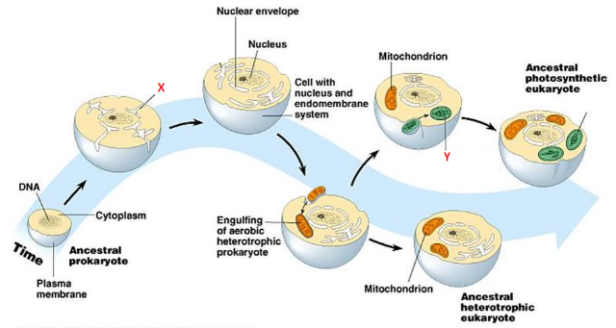
What does X represent in the given diagram?
A. Plastid
B. engulfing of photosynthetic prokaryotes
C. endoplasmic reticulum
D. Infoldings of plasma membrane
ANSWER: D

What does Y represent in the given diagram?
A. Plastid
B. engulfing of photosynthetic prokaryotes
C. endoplasmic reticulum
D. Infoldings of plasma membrane
ANSWER: B

